Delanay traingles edge lengths and pairwise distance

**Equidistant case:**

**Example 1:**

In the first example, the distance matrix is initialized with zeros and then traverse over all the triangle edges. Where the edge exist put that pixel value to 1.   
  
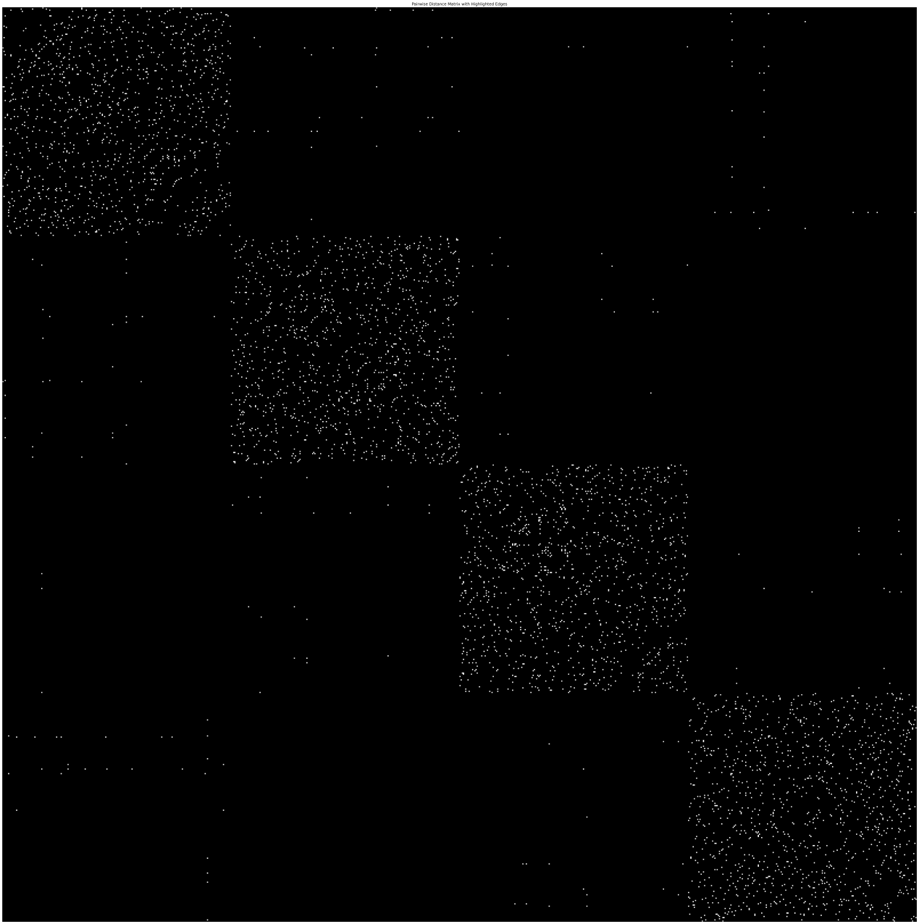

The above plot shows that delanay triangle creates most of the edges in intra-cluster region. As delanay traingulation is based on local connectivity I think that’s why it forms triangles with nearby points. And tsne somehow keeps intra cluster points close may be that’s why more edges are formed within clusters. Tsne also try to pushes cluster apart may be that’s also a reason.  
  
**Can we say that:  
Most delanay edges exist within clusters confirm that tsne preserve local structure and separate global structure?  
  
OR  
If Delaunay formed many inter-cluster edges, it means that t-SNE failed to separate clusters well?  
  
Example 2:**

In this example all edges are plotted with their length in high dimension (not with one as in previous example) and other pixels are zeros.

  
Here the bright pixels represents the edges who have large lengths. Now we are not seeing edges in intra cluster regions as their distances are low.  
  
**Second Task**

The interactive tool implemented work as follows:  
1. Draw two boxes on the plot.   
2. Create all possible edges between data points of first box with the second box.  
3. Then those edges are highlighted in the pairwise distance matrix plot.   
For highlighting, rectangle is created around the pixel.  
  
  
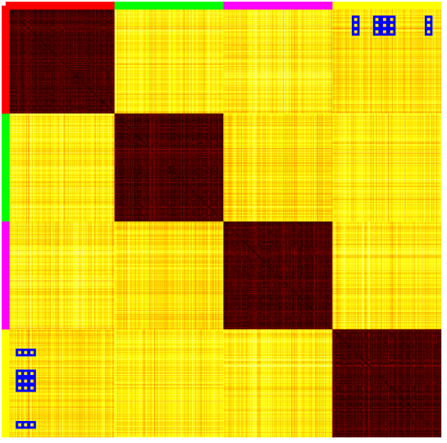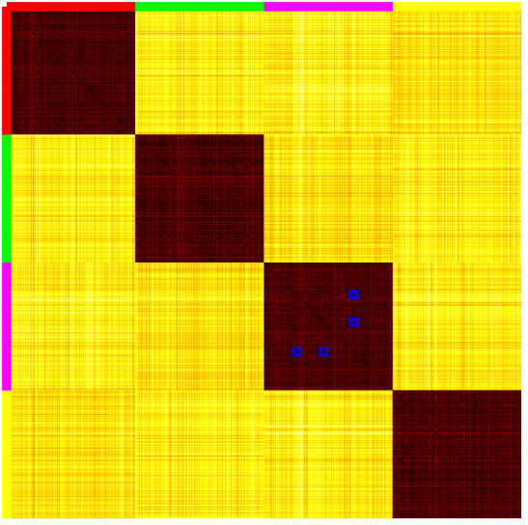

In left figure points of red and yellow clusters are interactively selected in the 2D space (tsne) and they are shown in their corresponding region in the pairwise distance plot.  
In the right figure, data points of purple cluster is selected and they are shown in their region in distance plot.  
  
For HAR datasets the code is working but It has some issues may be because it is very large size (7352, 7352) and matplotlib not showing them well.

**Real Dataset**

**Human activity recognition (HAR):**

**Version 1: Selecting points using rectangular (Box):**Two boxes are drawn over the plot and then edges are created between points in the two boxes. Then, edges are showed in pairwise distance matrix plot.

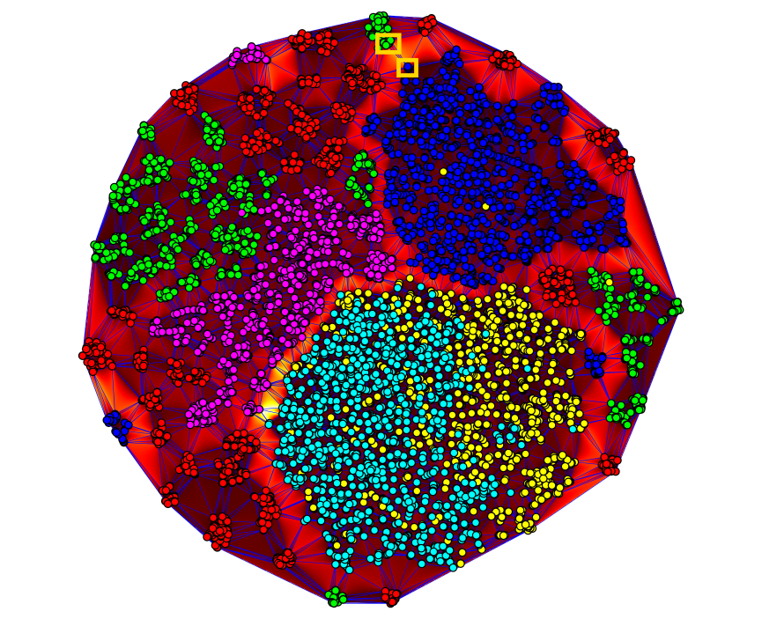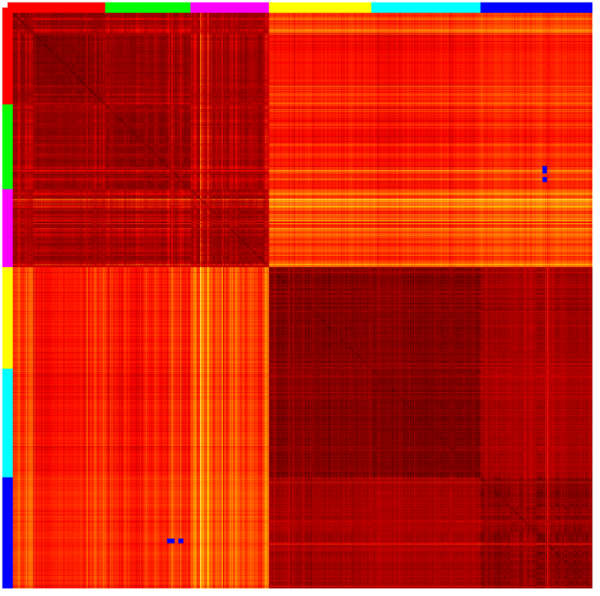

The edges of selected points (green and blue) in delaunay plot has high values and in distance plot those edges also show the region where the values are high.

**Version 2: Select two points using click**

Two points are selected and edge is drawn between them and then show them in pairwise distance matrix.  
  
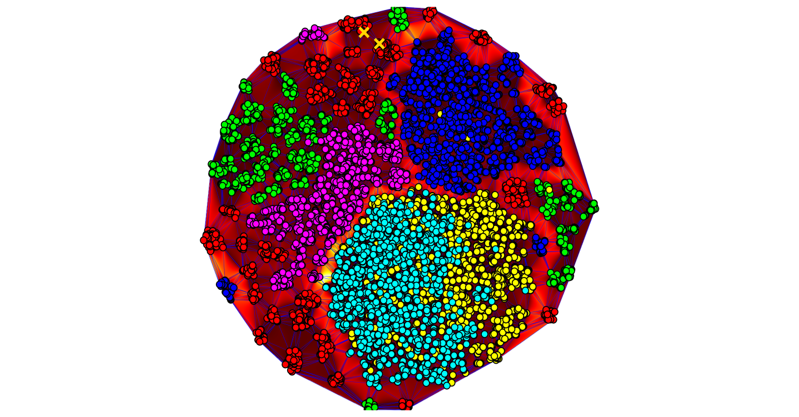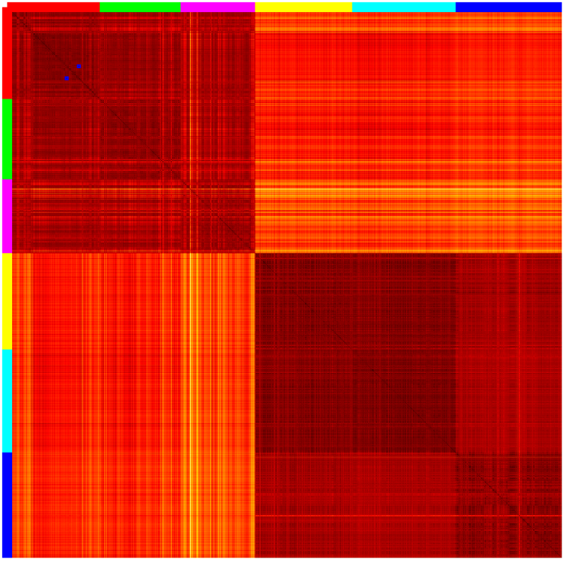

Two red cluster points are selected and the edge between them has low value. In distance plot that edge is also shown in the dark region.   
  
**Version 3**

**Select the edges.**Click on the edges or any place in the 2D space the closest edge to that clicked position is selected and then represented on the distance plot.  
  
  
  
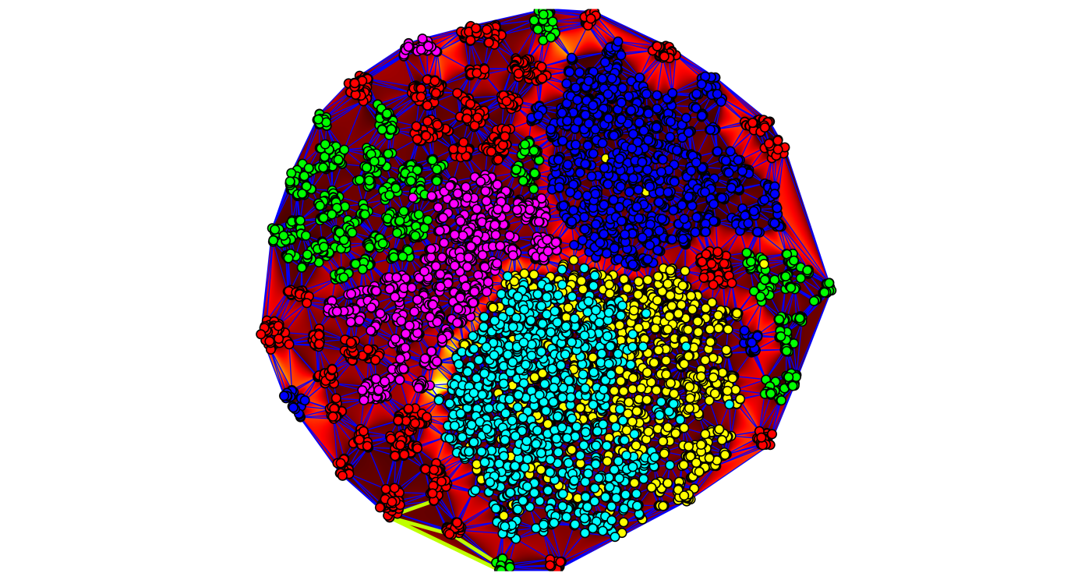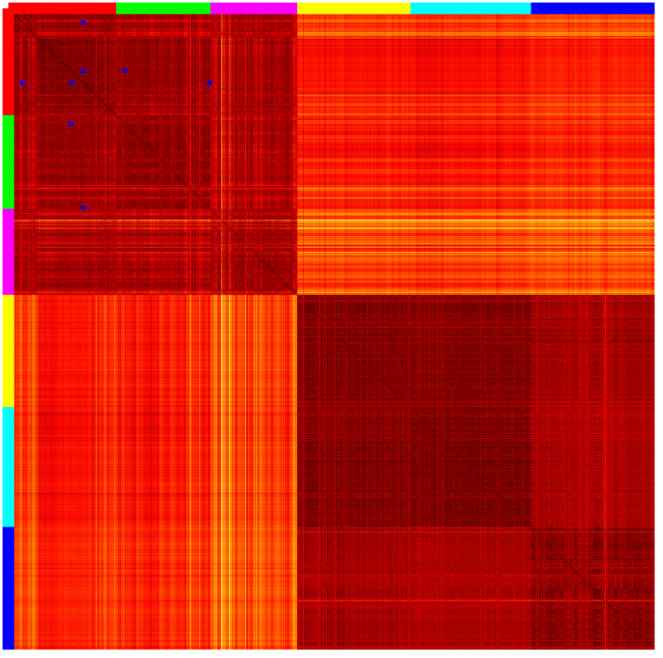

**Version 4:**

**Draw a line/curve**  
  
Draw a curve and the edges that intersect the curve are selected and represented on distance plot.

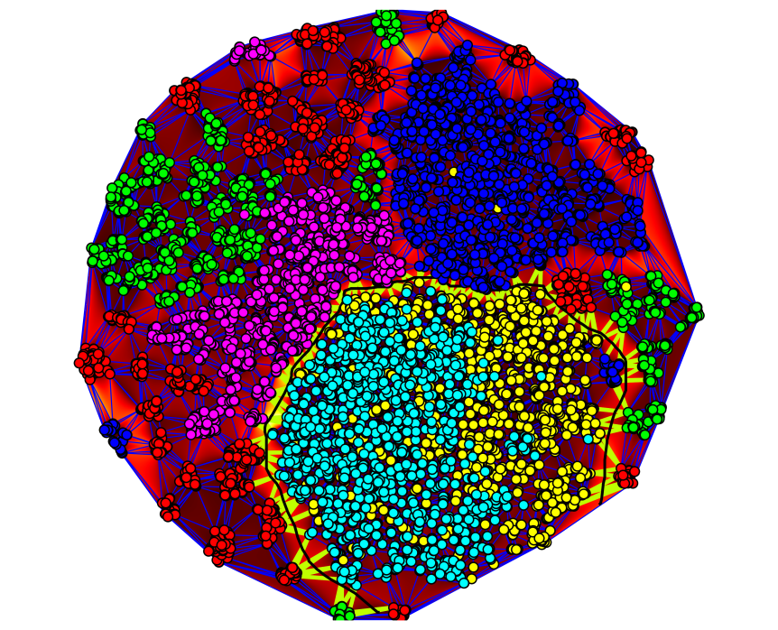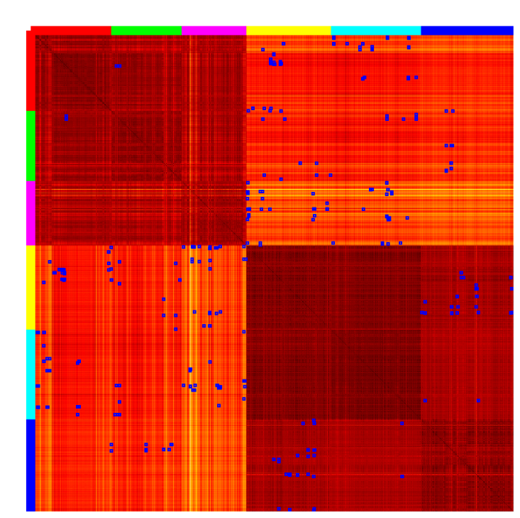

**Version 5  
Dynamic version of box selection:**  
  
A box is drawn on the plot to select a subset of points. All points that lie inside this box are identified as a cluster. Once the points are selected, intra-cluster edges are generated by connecting each pair of points within the selected cluster. A pairwise distance plot is generated using only the points selected in the current box. Then, second box is drawn to select another set of points, which creates a new cluster. For this new cluster, intra-cluster edges are again created as we do before. Also, inter-cluster edges are generated by connecting each point in the new cluster to each point in the previously selected clusters.The pairwise distance matrix is updated to include the new cluster by appending the corresponding rows and columns. It shows distances within the new cluster and between the new and previous clusters.

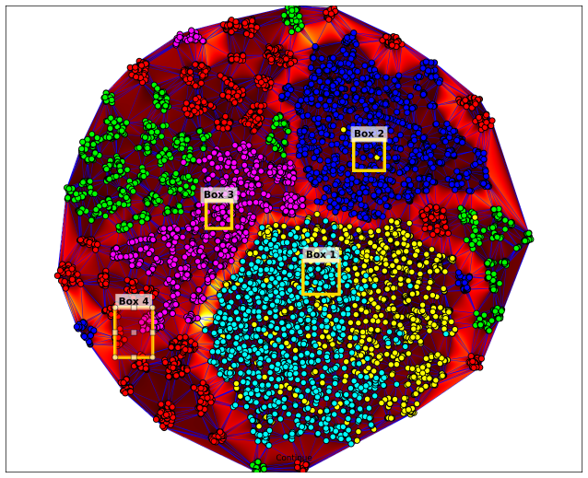 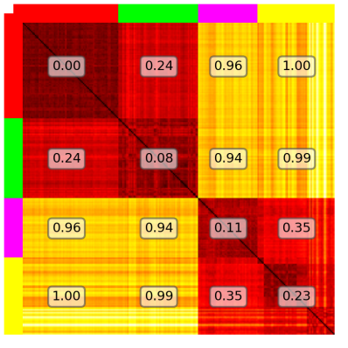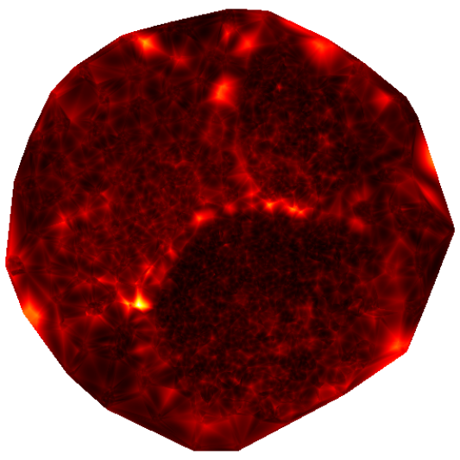

Barycentric cooridnates interpolation with high dim vertices

Pairwise distance plot

Barycentric interpolation high dim edges

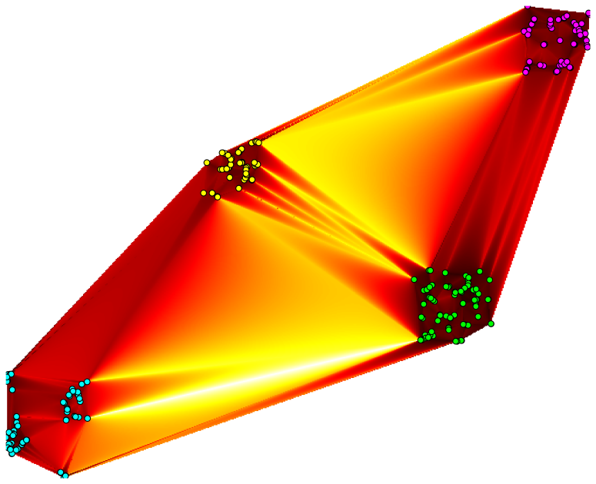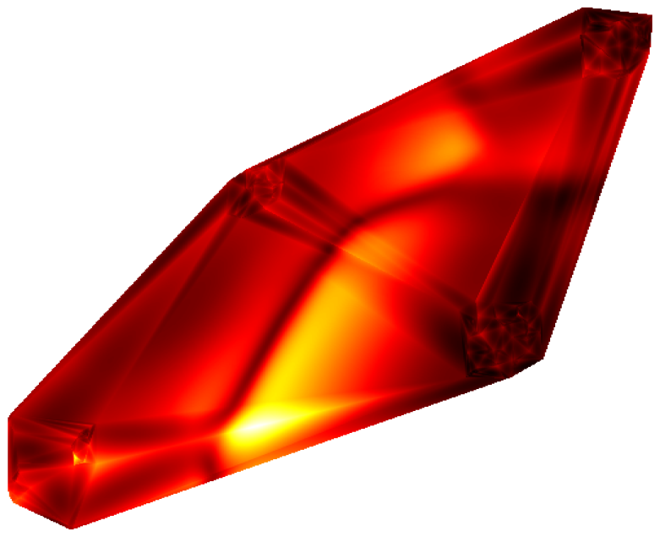

Barycentric interpolation Coordinates

Barycentric interpolation HD edge lengths

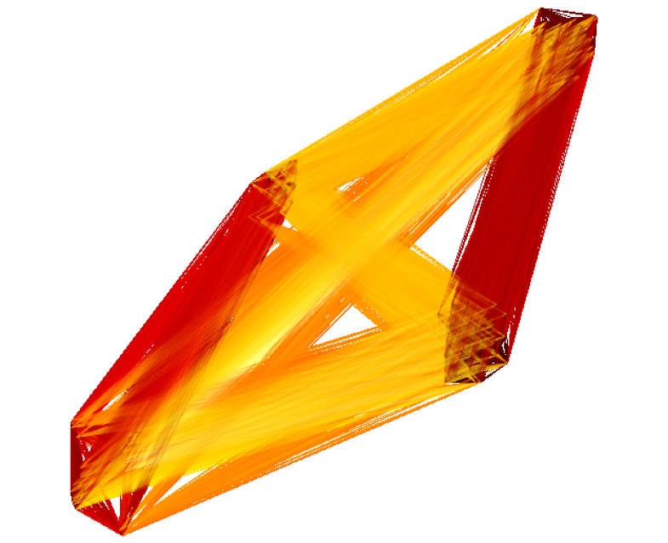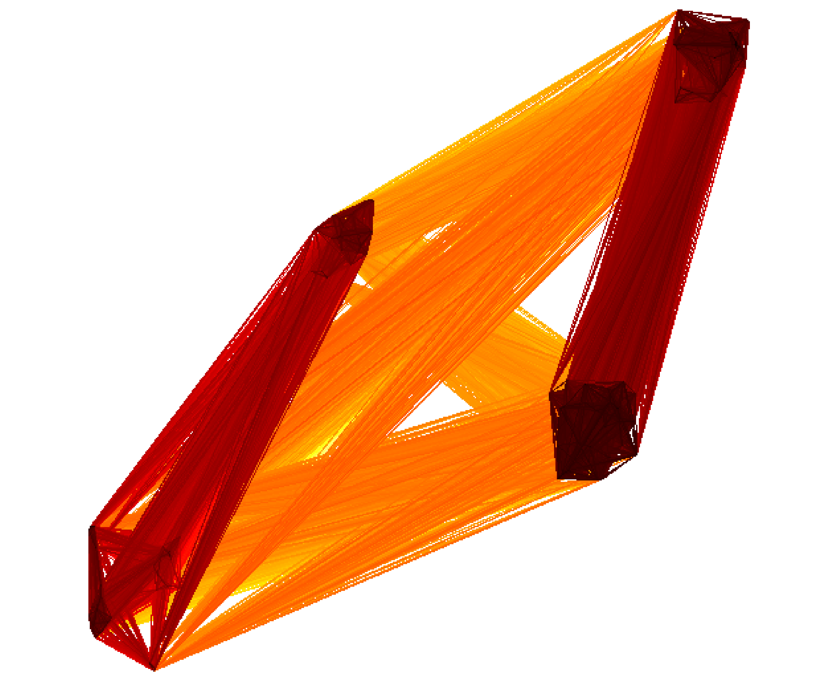

Fully connected sub edges with blending: Minimum

Fully connected sub edges with blending: Average

**24 - 4 -2025**

**HAR Dataset**

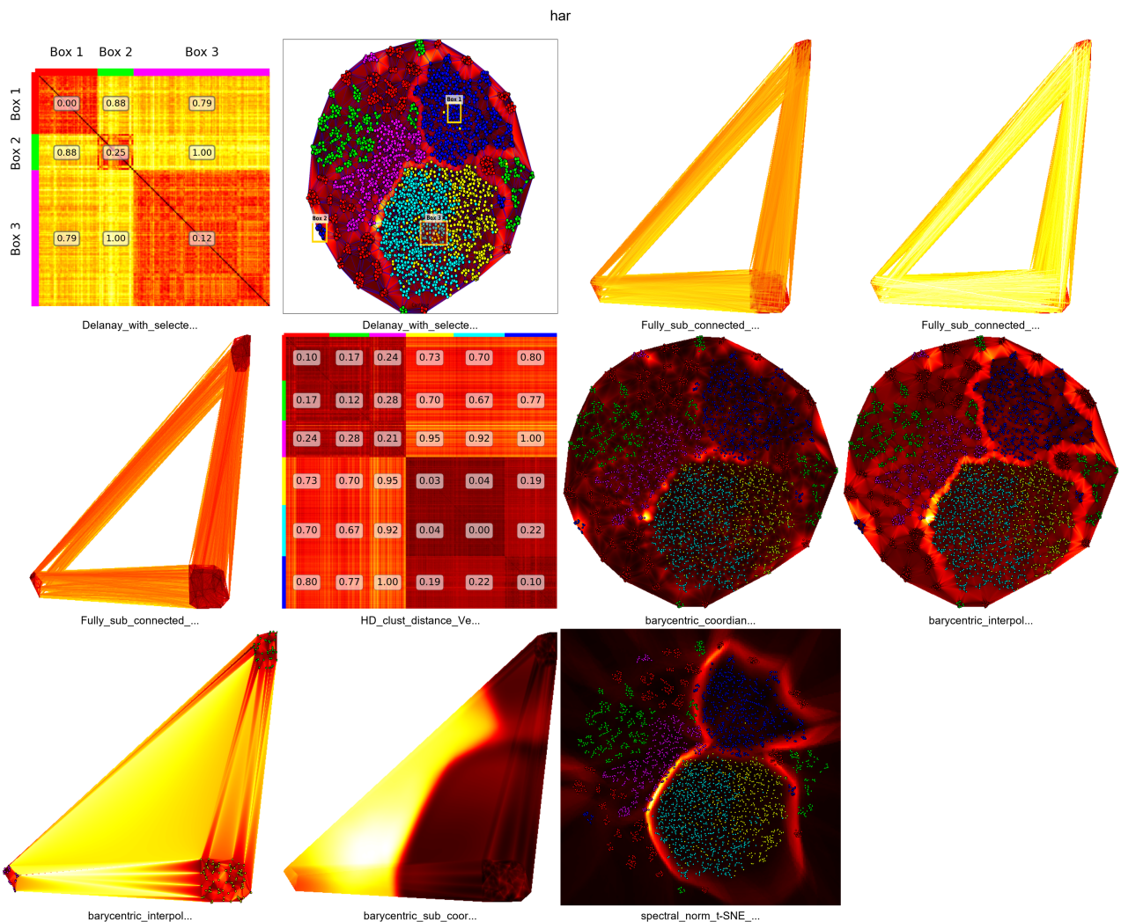

**Equidistant**

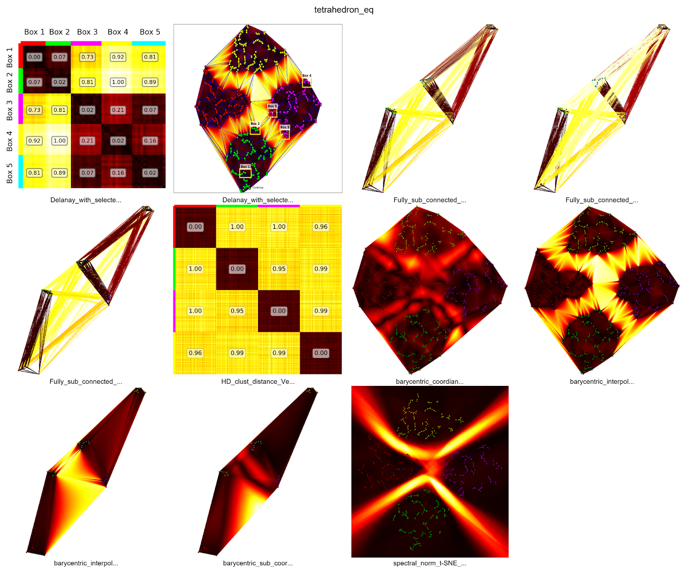

**1 far**

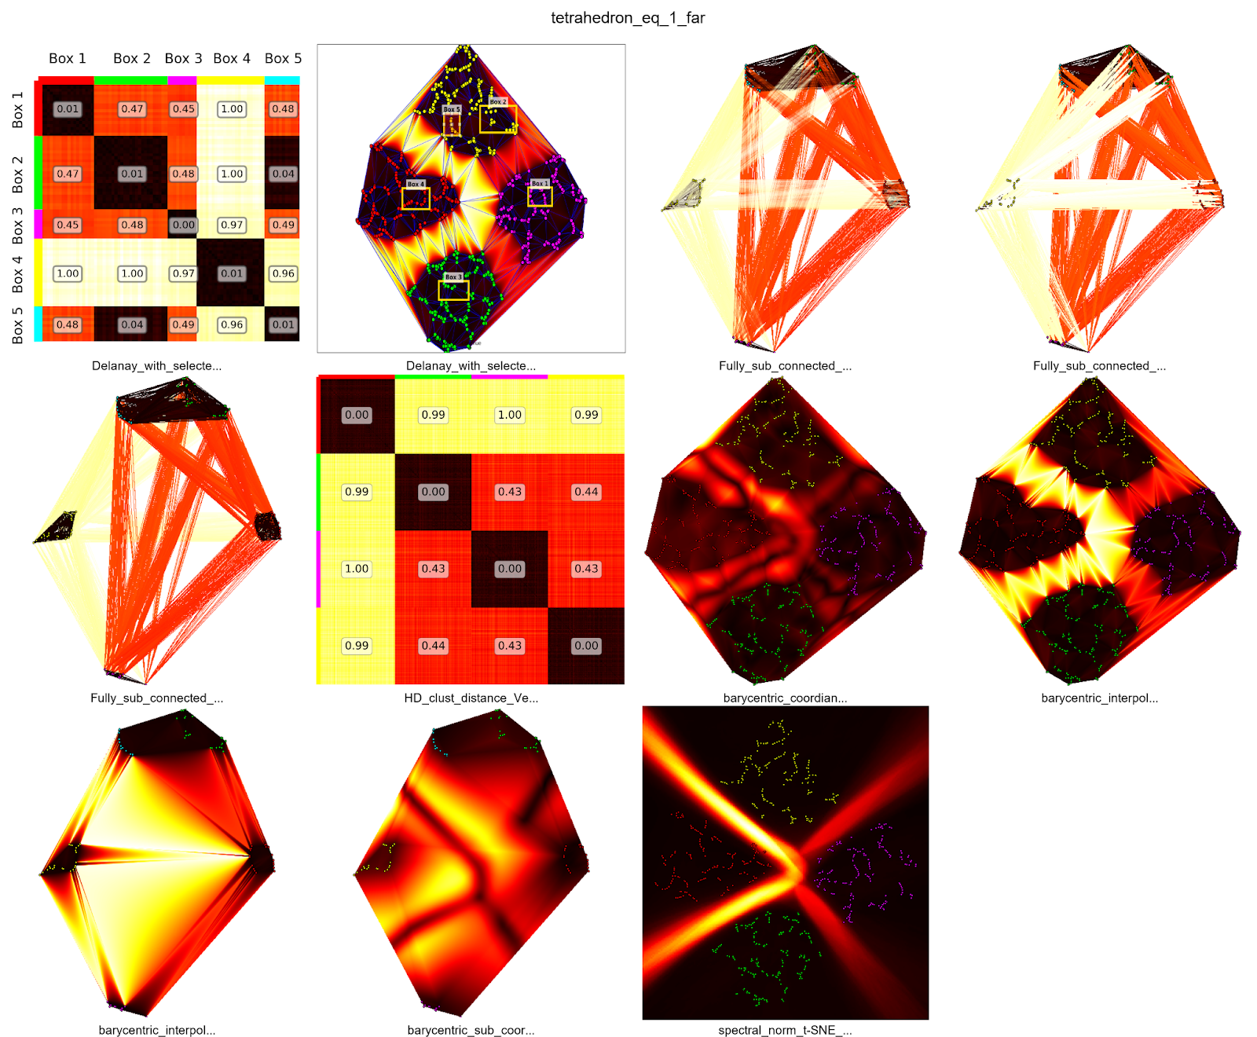

**1-Close**

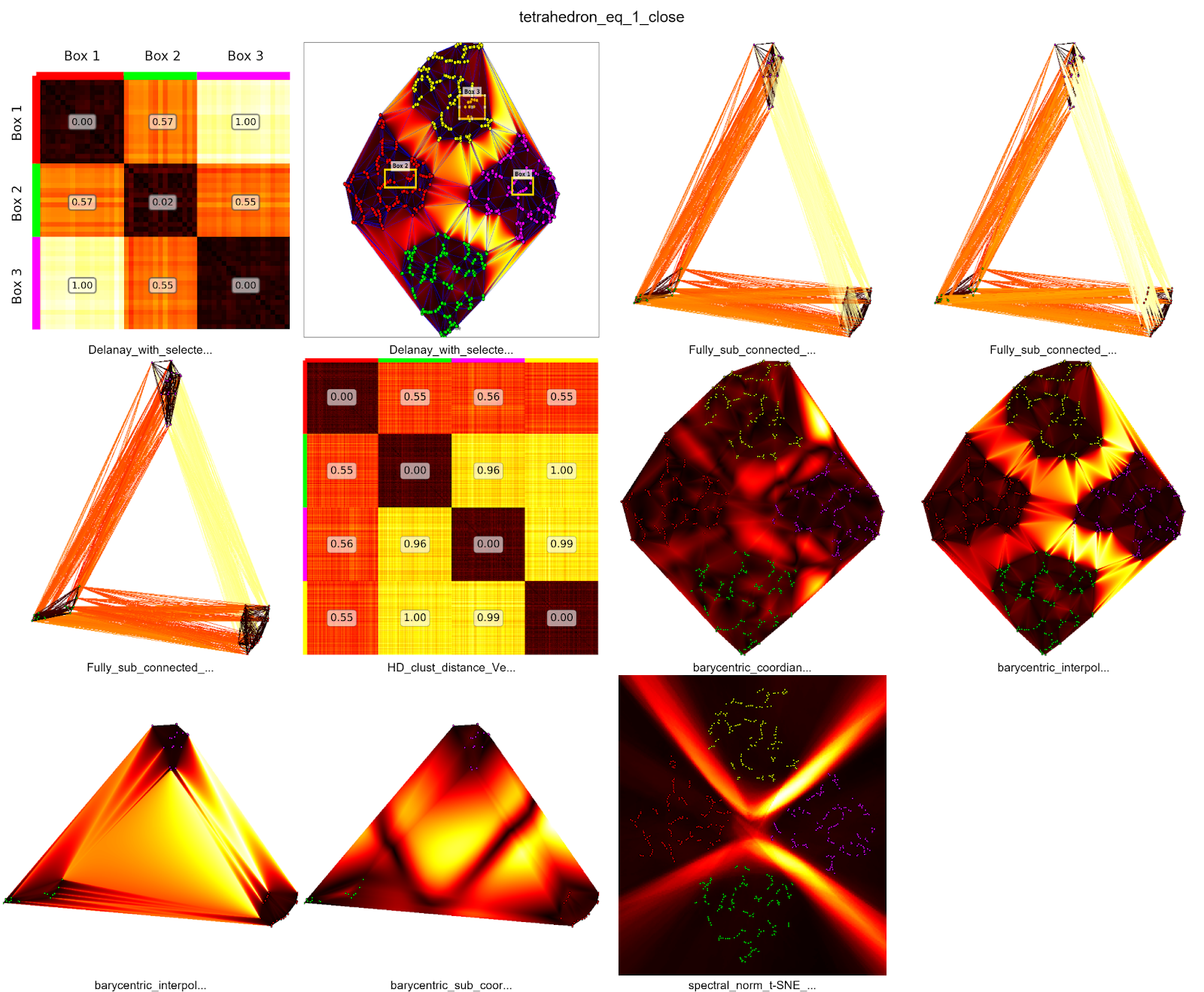

**2-Close**

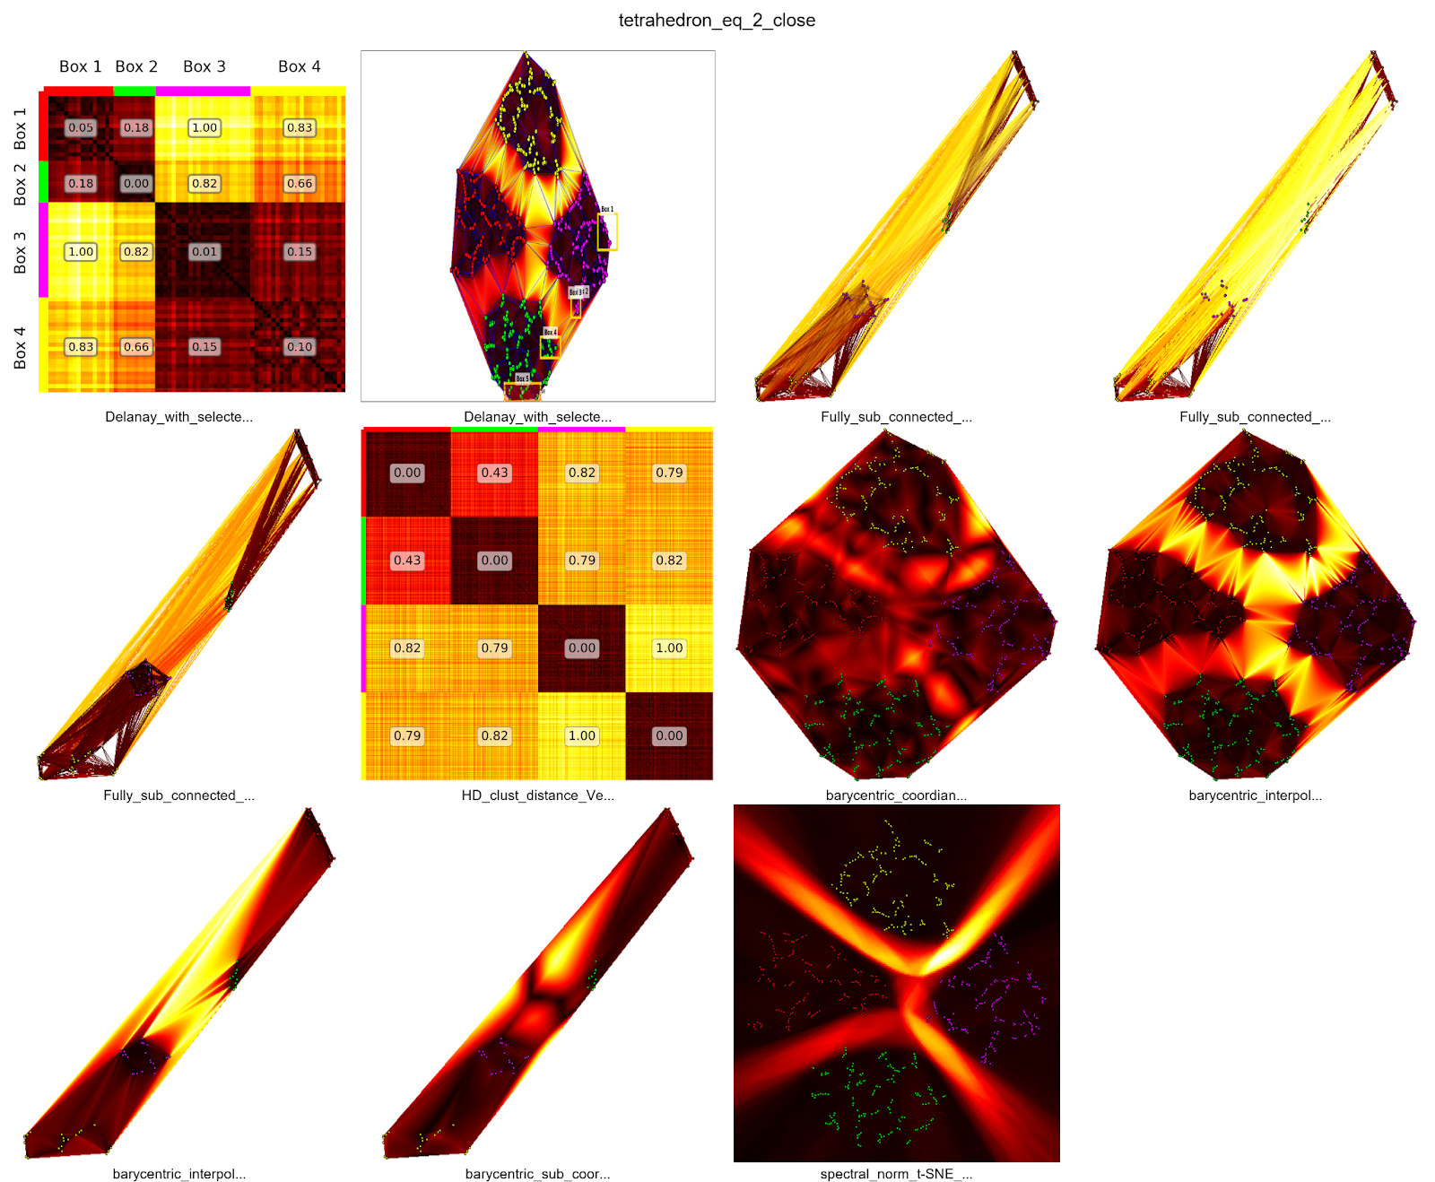

**High Dimension Datasets**

**Dim = 5**

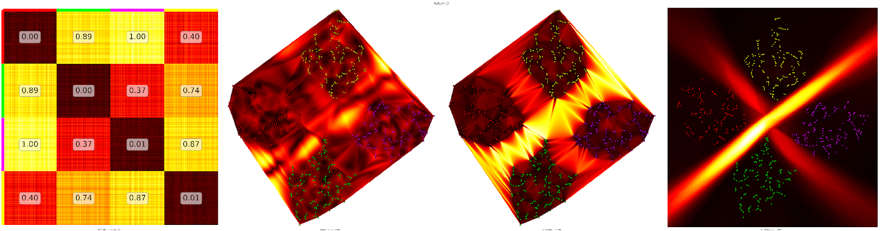

**Dim = 50**

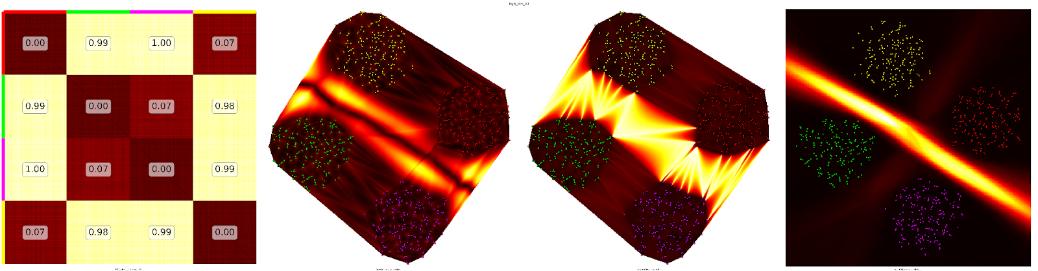

**Dim = 100**

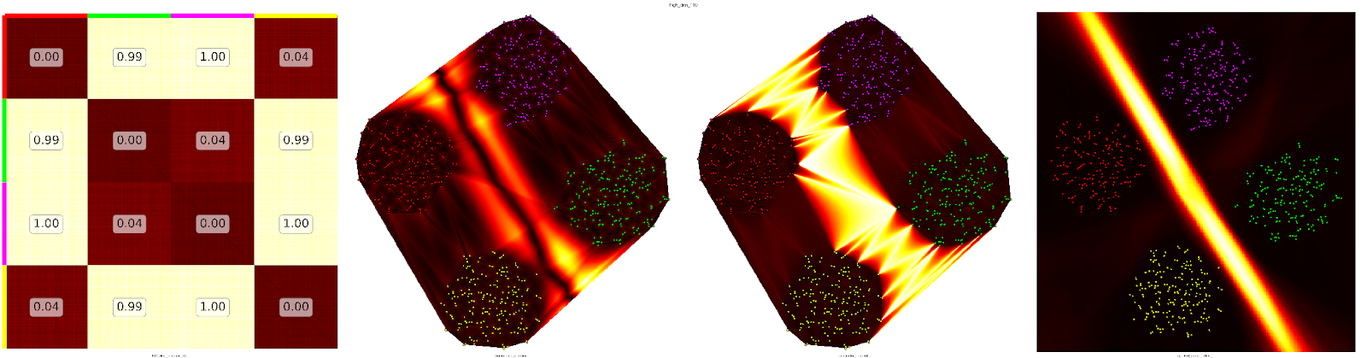

**Dim = 200**

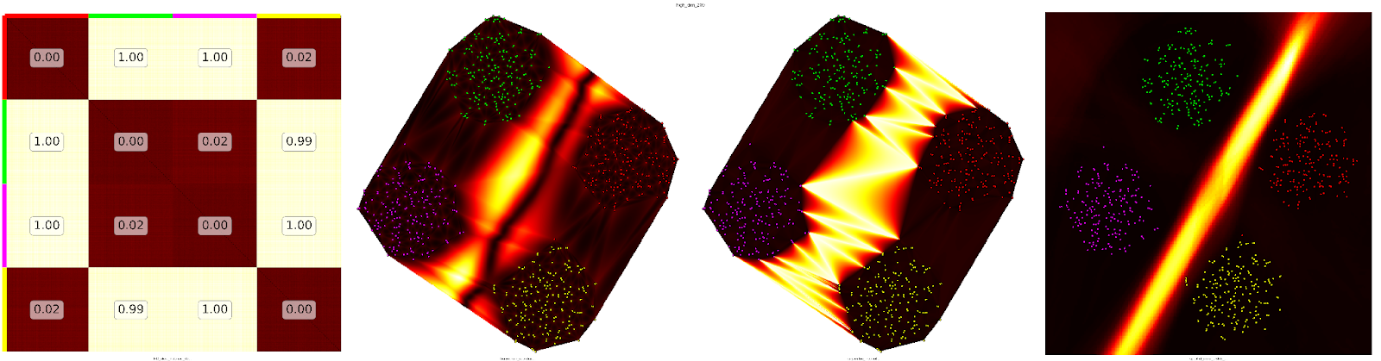

**Dim = 500**

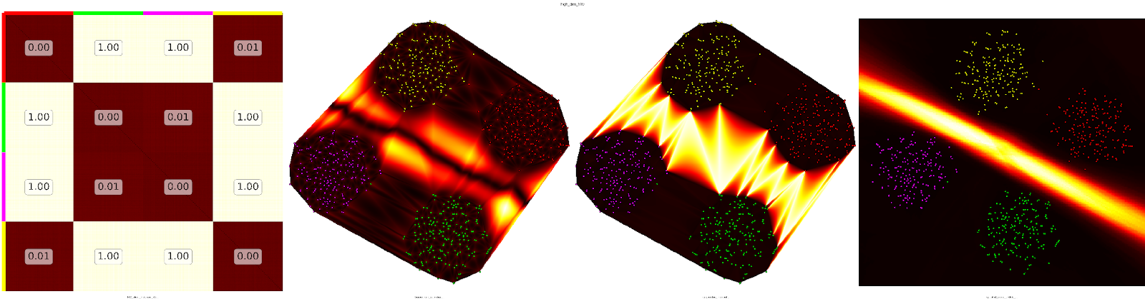

**Wine Dataset**

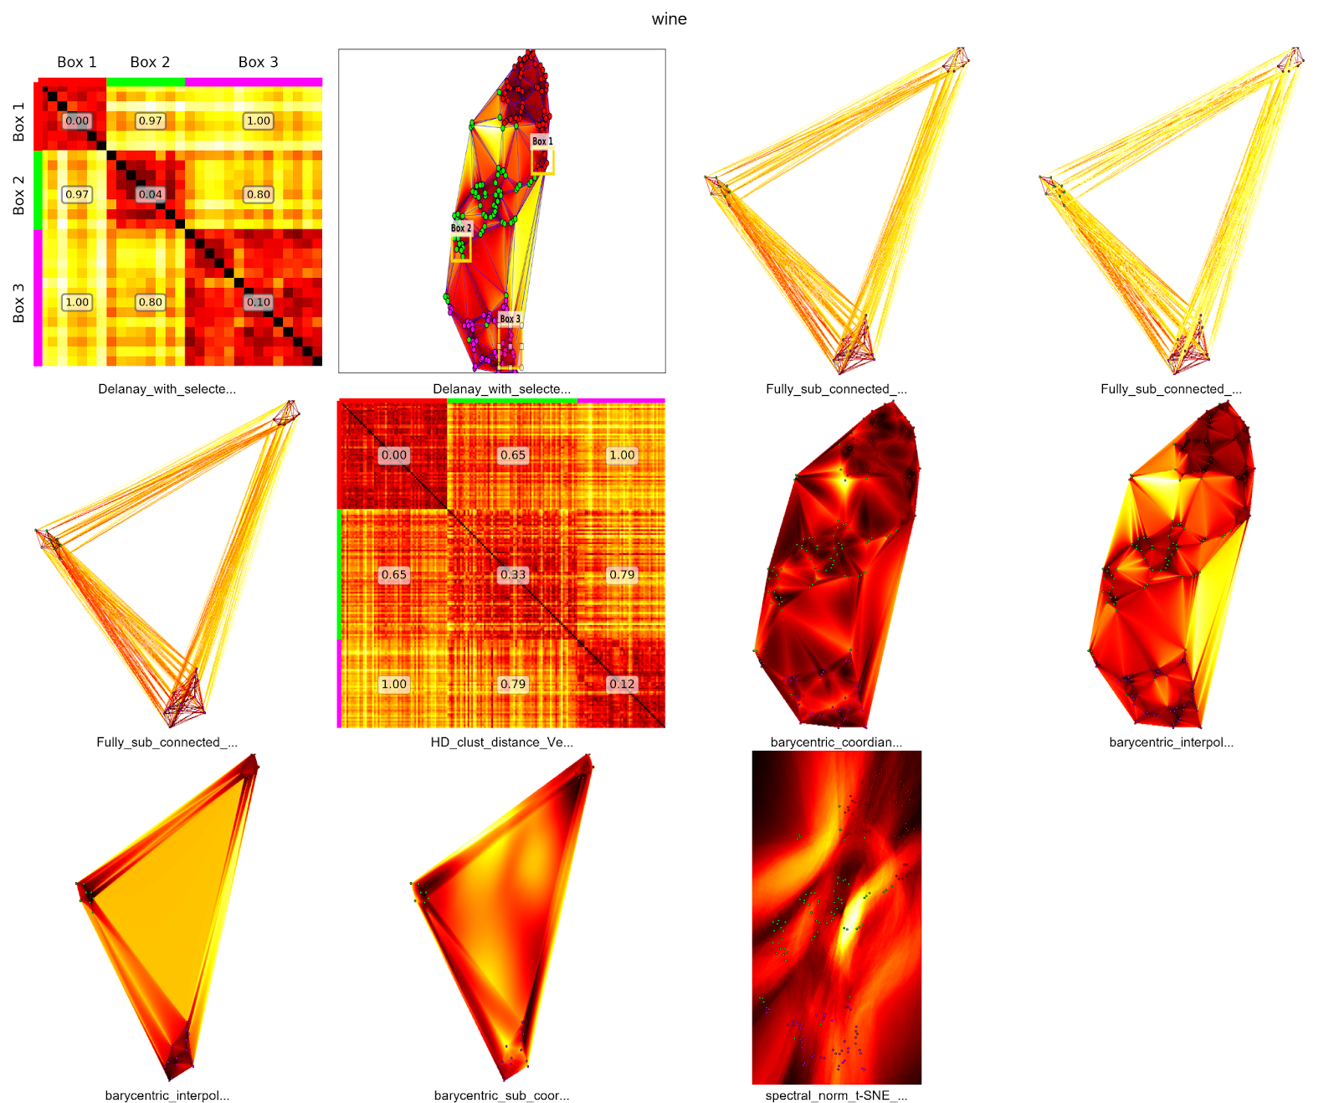

**Digits**

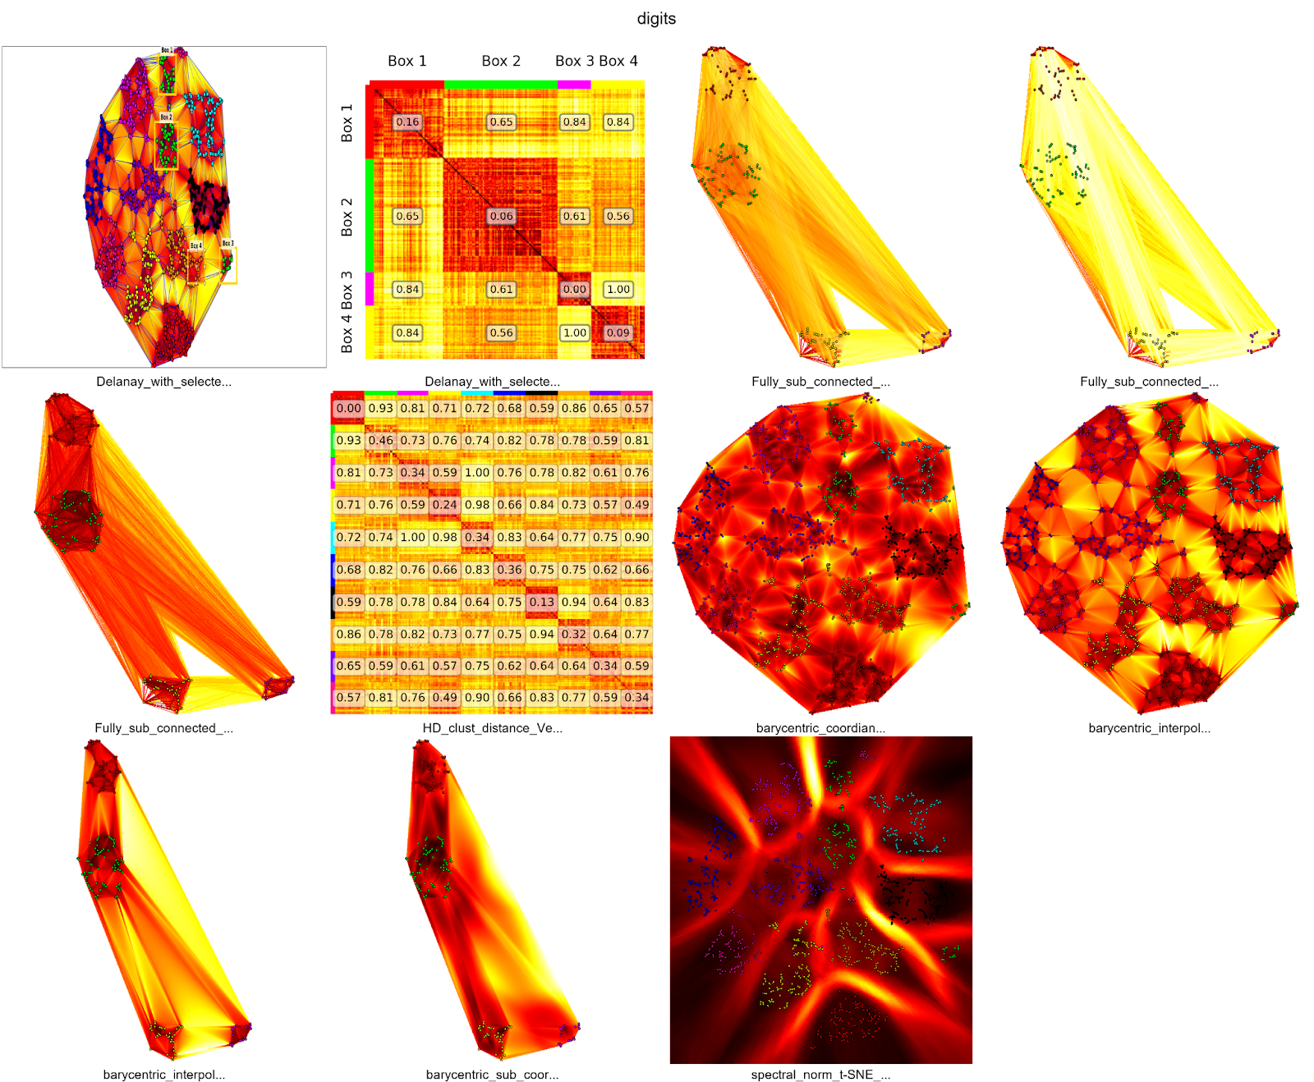

|  |  |  |  |
| --- | --- | --- | --- |
| **Datasets** | **Instances** | **Dimension** | **Classes** |
| **HAR** | 10299 | 561 | 6 |
| **digits** | 1797 | 64 | 10 |
| **Iris** | 150 | 4 | 3 |
| **wine** | 178 | 13 | 3 |